Lab 5 Problem Solving Concepts with Python

Lab 5A, 5B, 5C, 5D – Repetition Structures (100 pts.)

Lab 5A – Calories Burned

Repetition Structure: for loop with a range of values

Objectives:
The objectives of this lab exercise are to:
- Create a flowchart:
  - The flowchart will assist you in designing the Python solution for the calories burned problem (see below problem details) in the Programming and Logic Design textbook.
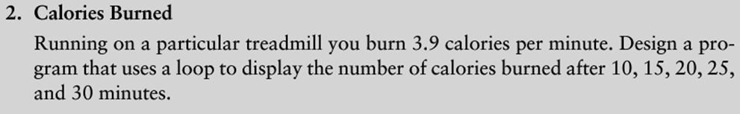
  - Refer to Appendix B of the Programming and Logic Design Textbook for the flowchart symbols.
  - Include the use of a repetition structure, for loop
  - Include global variables in your solution or use return statements.
  - Use Microsoft Visio or any other flowcharting tool. There are many free apps available for mobile devices.

- Write the out the pseudo code needed to solve this problem.
- Solve the problem through a Python programming solution.
  - Include a repetition structure.
  - Refer to chapter 5, section 5.3 for hints.
A count-controlled loop should be used, “for loop.”

for num in [10,15,20,25,30]:

Hint – See Python Language Companion guide page 42.

  - Copy and paste the output at the end of the program code.
    - Use triple quotes to indicate multi-line comment.

- (5 pts.) - Flow chart – Calories Burned
  - Correctly use the flowchart symbols in your flowchart.
  - Include the start and end of the program in your flowchart.
  - Include arrows to show the flow through the program.
  - Add labels to the flow chart symbols for readability.
  - Include the repetition structure in the flow chart.

- (5 pts.) – Pseudo code – Calories Burned
  - Write the pseudo code to solve the problem.

- (15 pts.) – Python Program: Calories Burned
- Use IDLE, MS Visual Studio 2013 or Eclipse for Python 3.4.1.
- Write the Python source code based on your flowchart, and pseudo code.

#=============================================================
# Course-Lab: CS104 -- Lab-05A – Calories Burned
# Filename: Lab5A_CaloriesBurned.py
# Author: <Your name>
# Purpose: <Write out your own purpose for lab 5A. >
#=============================================================

Deliverable(s): Lab5A– Calories Burned

- Hand in the printed Python source code for Lab5A listed above.
  - Test the program three times.
  - Include the outputs from running the code by pasting into the source code.
    - Use triple sets of quotes around the output.
- Hand in the printed flow chart, and pseudo code for Lab5A.
- Submit electronic versions of the lab files.
  - .py file, and the output
  - Flow chart
  - Pseudo code

Lab 5B – Sum of Numbers

Repetition Structure: while loop

Objectives:
The objectives of this lab exercise are to:
- Create a flowchart:
  - The flowchart will assist you in designing the Python solution for the sum of numbers problem (see below problem details) in the Programming and Logic Design textbook.
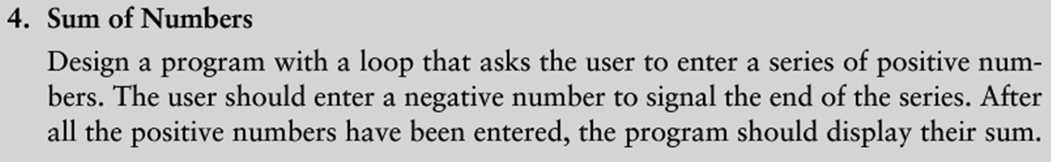
  - Refer to Appendix B of the Programming and Logic Design Textbook for the flowchart symbols.
  - Include the use of a repetition structure.
  - Include global variables in your solution or use return statements.
  - Use Microsoft Visio or any other flowcharting tool. There are many free apps available for mobile devices.

- Write the out the pseudo code needed to solve this problem.
- Solve the problem through a Python programming solution.
  - Include a repetition structure, while loop
  - Refer to the Python 3 Language Companion for the Gaddis textbook.
  - Refer to the example on calculating running totals in chapter 5, section 5.4
  - Copy the output at the end of the program code. Use triple quotes to indicate multi-line comment.

- (5 pts.) - Flow chart – Sum of Numbers
  - Correctly use the flowchart symbols in your flowchart.
  - Include the start and end of the program in your flowchart.
  - Include arrows to show the flow through the program.
  - Include the repetition structure in the flow chart.
    - Allow the user to enter five numbers.
  - Add labels to the flow chart symbols for readability.

- (5 pts.) – Pseudo code – Sum of Numbers
  - Write the pseudo code to solve the sum of numbers problem.
  - Allow the user to enter five numbers.

- (15 pts.) – Python Program: Sum of Numbers
- Use IDLE, MS Visual Studio 2013 or Eclipse for Python 3.4.1.
- Write the Python source code based on your flowchart, and pseudo code.

#=============================================================
# Course-Lab: CS104 -- Lab-05B – Sum of Numbers
# Filename: Lab5B_SumNumbers.py
# Author: <Your name>
# Purpose: <Write out your own purpose for lab 5B>
#=============================================================

Deliverable(s): Lab5B – Sum of Numbers

- Hand in the printed Python source code for Lab5B listed above.
  - Test the program three times.
  - Include the outputs from running the code by pasting into the source code.
    - Use triple sets of quotes around the output.
- Hand in the printed flow chart, and pseudo code for Lab5B.
- Submit electronic versions of the lab files.
  - .py file and the output
  - Flow chart
  - Pseudo code

Lab 5C– Celsius to Fahrenheit

Repetition Structure: for loop

Objectives:
The objectives of this lab exercise are to:
- Create a flowchart:
  - The flowchart will assist you in designing the Python solution for the Celsius to Fahrenheit (see below problem details) in the Programming and Logic Design textbook.
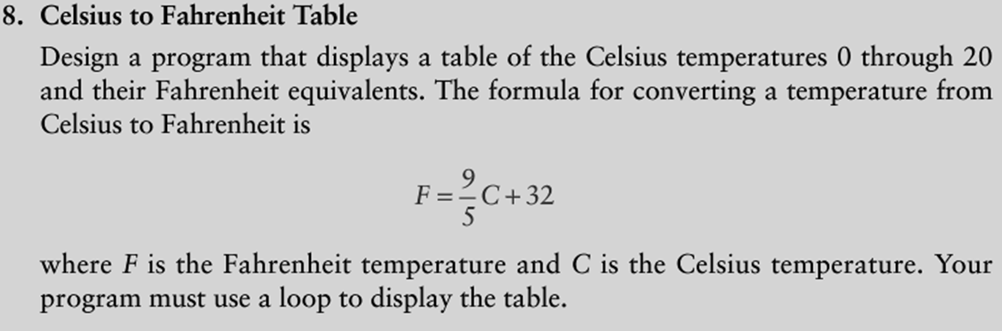
  - Refer to Appendix B of the Programming and Logic Design Textbook for the flowchart symbols.
  - Include the use of a repetition structure.
  - Include global variables in your solution or use return statements.
  - Use Microsoft Visio or any other flowcharting tool. There are many free apps available for mobile devices.

- Write the out the pseudo code needed to solve this problem.
- Solve the problem through a Python programming solution.
  - Include a repetition structure, for loop with a counter
  - Refer to the Python 3 Language companion document.
  - Refer to the example on calculating running totals in chapter 5, section 5.4

for num in []:

Note: Inside of the [] type in the values to be used in the loop

  - Copy the output at the end of the program code. Use triple quotes to indicate multi-line comment.

Lab 5C Specifications: Celsius to Fahrenheit

- (5 pts.) - Flow chart – Celsius to Fahrenheit
  - Correctly use the flowchart symbols in your flowchart.
  - Include the start and end of the program in your flowchart.
  - Include arrows to show the flow through the program.
  - Include the repetition structure in the flow chart.

- (5 pts.) – Pseudo code – Celsius to Fahrenheit
  - Write the pseudo code to solve the calories burned problem.

- (15 pts.) – Python Program: Celsius to Fahrenheit
- Use IDLE, MS Visual Studio 2013 or Eclipse for Python 3.4.1.
- Write the Python source code based on your flowchart, and pseudo code.

#=============================================================
# Course-Lab: CS104 -- Lab-05C – Celsius to Fahrenheit
# Filename: Lab5C_CelsiusFahrenheit.py
# Author: <Your name>
# Purpose: <Write out your own purpose for lab 5C>.
#=============================================================

Deliverable(s): Lab5C– Celsius to Fahrenheit

- Hand in the printed Python source code for Lab5C listed above.
  - Test the program three times.
  - Include the outputs from running the code by pasting into the source code.
    - Use triple sets of quotes around the output.
- Hand in the printed flow chart, and pseudo code for Lab5C.
- Submit electronic versions of the lab files.
  - .py file and the output
  - Flow chart
  - Pseudo code

Lab 5D – Bugs Collected

Repetition Structure: counter controlled while loop or for loop

Objectives:
The objectives of this lab exercise are to:
- Create a flowchart:
  - The flowchart will assist you in designing the Python solution for the bugs collected problem (see below problem details) in the Programming and Logic Design textbook.
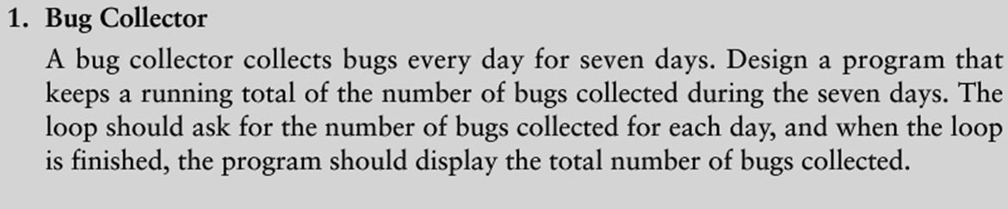
  - Refer to Appendix B of the Programming and Logic Design Textbook for the flowchart symbols.
  - Include the use of a repetition structure. counter controlled while or for loop
  - Include global variables in your solution or use return statements.
  - Use Microsoft Visio or any other flowcharting tool. There are many free apps available for mobile devices.

- Write the out the pseudo code needed to solve this problem.
- Solve the problem through a Python programming solution.
  - Include a repetition structure.
  - Refer to chapter 5 for hints.

counter controlled while loop or for loop

  - Copy and paste the output at the end of the program code.
    - Use triple quotes to indicate multi-line comment.

- (5 pts.) - Flow chart – Bug Collected
  - Correctly use the flowchart symbols in your flowchart.
  - Include the start and end of the program in your flowchart.
  - Include arrows to show the flow through the program.
  - Add labels to the flow chart symbols for readability.
  - Include the repetition structure in the flow chart.

- (5 pts.) – Pseudo code – Bug Collected
  - Write the pseudo code to solve the problem.

- (15 pts.) – Python Program: Bugs Collected
- Use IDLE, MS Visual Studio 2013 or Eclipse for Python 3.4.1.
- Write the Python source code based on your flowchart, and pseudo code.

#=============================================================
# Course-Lab: CS104 -- Lab-05D – Bugs Collected
# Filename: Lab5D_BugsCollected.py
# Author: <Your name>
# Purpose: <Write out your own purpose for lab 5D. >
#=============================================================

Deliverable(s): Lab5D– Bugs Collected

- Hand in the printed Python source code for Lab5D listed above.
  - Test the program three times.
  - Include the outputs from running the code by pasting into the source code.
    - Use triple sets of quotes around the output.
- Hand in the printed flow chart, and pseudo code for Lab5D.
- Submit electronic versions of the lab files.
  - .py file and the output
  - Flow chart
  - Pseudo code

